# **Clustering and exploring Venues in the Jersey City Neighborhoods**

**A.Introduction**

**A.1 Background and Data Description:**

**A.1.1 Background**

I am writing this article as a part of the IBM Data Science Professional Certificate available on Coursera. Jersey City is widely recognized as a major American city and is the third-largest city in the New York Metropolitan area, behind New York City (NYC) and Newark. It, as well as the surrounding communities of Hudson County, are often referred to as the "Sixth Borough" of NYC, due to its proximity, density, and level of urban infrastructure that so closely resembles the City of New York. Because of its closeness with NYC, Jersey City often becomes a less expensive option for people who cannot afford to stay in NYC.

Therefore, this project is aimed at identifying places to live and hang out in Jersey City. I mainly focused on the house affordability for renting and buying in the Jersey City districts. And, also explored the city to find similar neighborhoods in terms of the type of venues, by using an unsupervised Machine Learning algorithm. And finally, to find better quality eating places to have regular meals in the neighborhood through exploratory analysis.

**A.1.2 Data Description:**

I used Foursquare API to acquire the data regarding the venues in the Jersey City neighborhoods i.e, the venue names and their types for each of the neighborhoods. Furthermore, house affordability data was taken from the Jersey City Open Data platform (Link). House affordability of districts is determined based on the availability of the number of affordable housing units in each district and categorized on that basis.

Location data of Jersey City districts and its neighborhoods was obtained in the form of spatial files from the Jersey City Open Data platform.

1. Spatial file with Jersey City neighborhood location data was cleaned and converted into Latitude and Longitude format. Moreover, the Foursquare API was used to obtain the most common venue in these neighborhoods based on the location data extracted from the spatial file. Later on, neighborhoods were clustered based on the most common type of venue in these neighborhoods and visualized using folium.
2. District level spatial data with house affordability unit's information was also cleaned and converted to longitude and latitude format.

**B. Methodology**

I created two data tables, one with neighborhood-level location (coordinates). The other one had district level location (coordinates) with house affordability unit's information.

First of all, I used the folium library to visualize the geographic details of Jersey City and its neighborhoods.

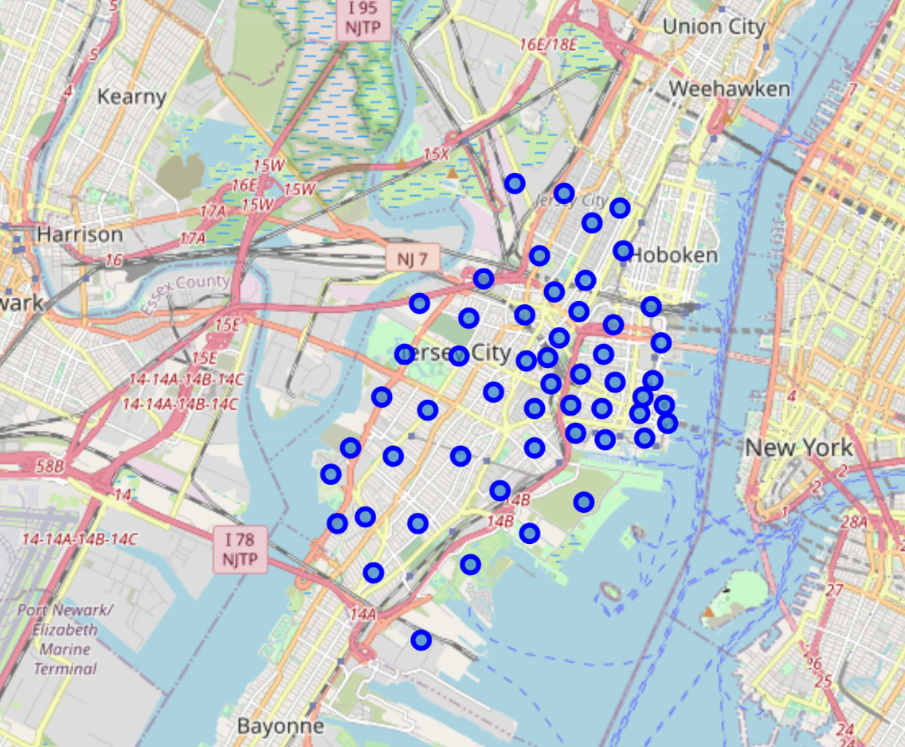

Next, I fetched a maximum of 100 venues in each Jersey City neighborhood, up to a range of 800 meters using the Foursquare API using the neighborhood level location. The Foursquare API has the 'explore API' feature, which allows us to find venue information within a given radius from the given coordinates. I used this API to find the venues for each neighborhood.

The Foursquare API returned a total of 2772 venues. Below is a merged table of neighborhood coordinates and venues.

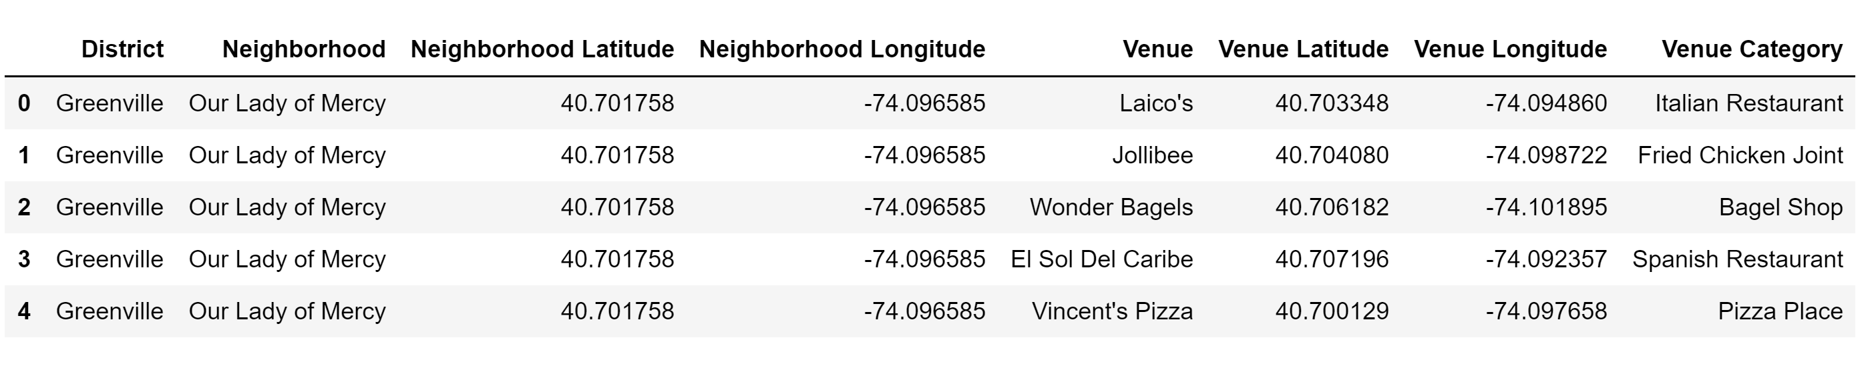

In the process of exploring the Jersey City neighborhoods, I used one of the simplest and most popular unsupervised machine learning algorithm called ‘K means clustering’ to identify any relationship between the Jersey City neighborhoods based on the category of the venues, if any. It will cluster similar neighborhoods together as per the type of venues available in each of these neighborhoods.

I ran K-Means to cluster the neighborhoods into **8** clusters because when I analyzed the K-Means with the elbow method, it provided me the 8 degree for optimum k of the K-Means.

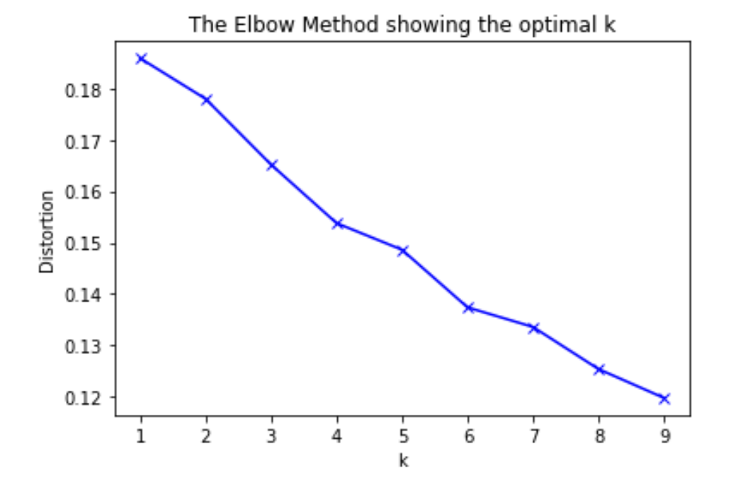

Each neighborhood was labeled as per their cluster, here is the head of the table with cluster labels for each neighborhood.

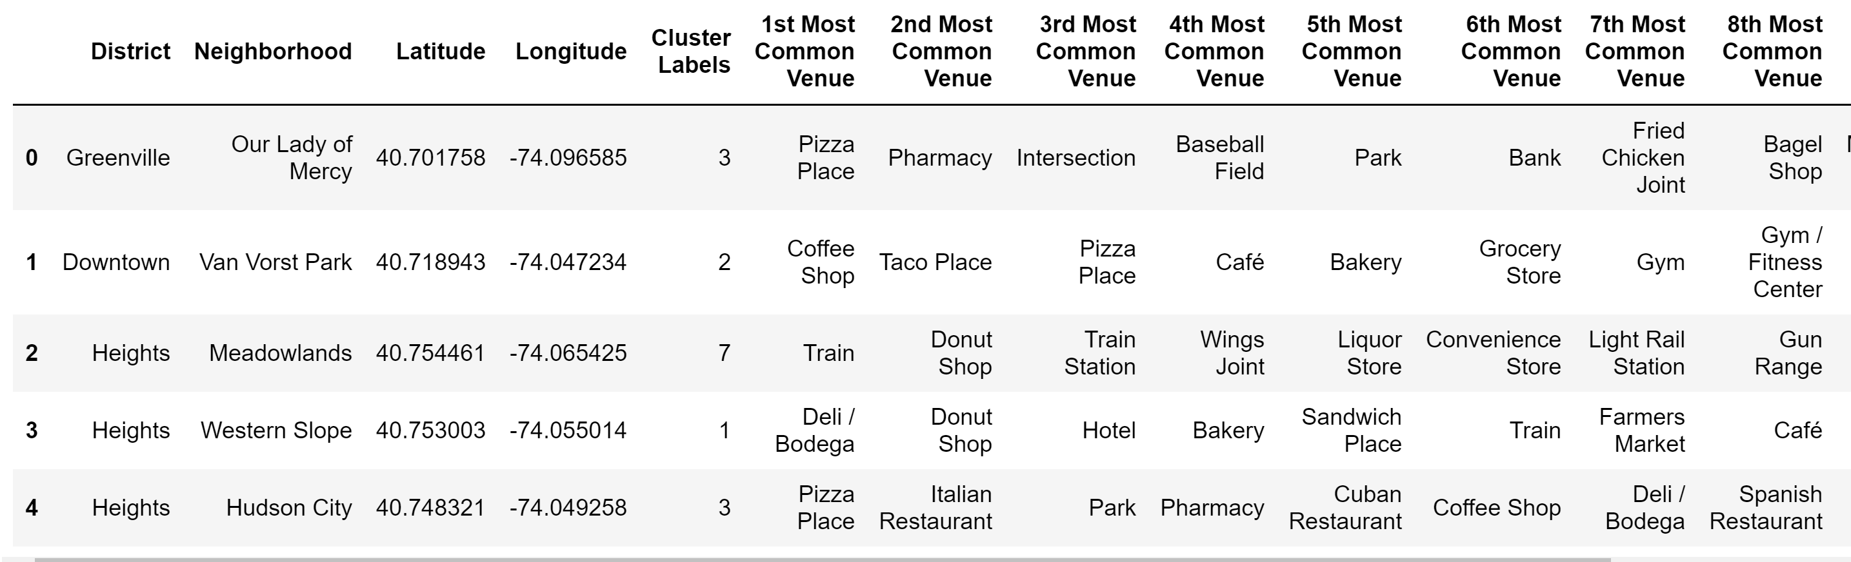

Afterwards, I cleaned district level data with number of house affordability unit’s information and created a separate category to define the house affordability for each district. Below is the table

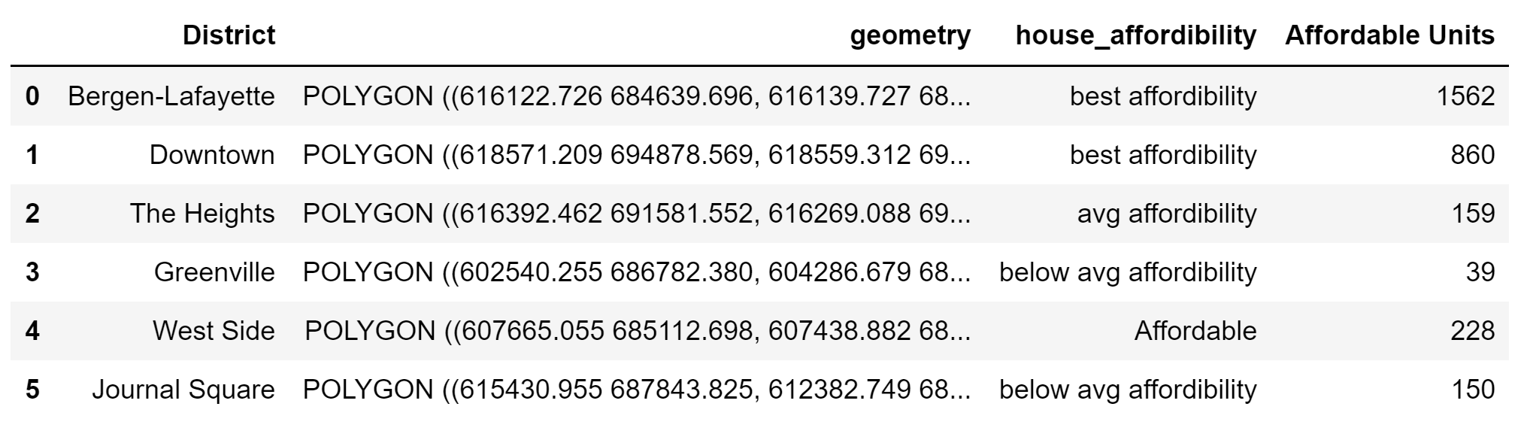

Later, I explored the neighborhoods further to find out the good quality places to eat. I considered only the restaurants out of all the venue categories. Since I could not obtain the venue rating data for each restaurant using a free developer Foursquare account, I extracted only the customer likes numbers for each restaurant and categorized them into 'Poor,' 'Okay,' 'Good,' 'Very Good,' and 'Excellent.' Subsequently, I also color-coded them based on the rating categories as - Red: Poor; Orange: Okay; Green: Good; Dark green: Very good; Blue: Excellent. Here is the resultant table.

**Histogram depicting the distribution of customer likes acquired by each restaurant**

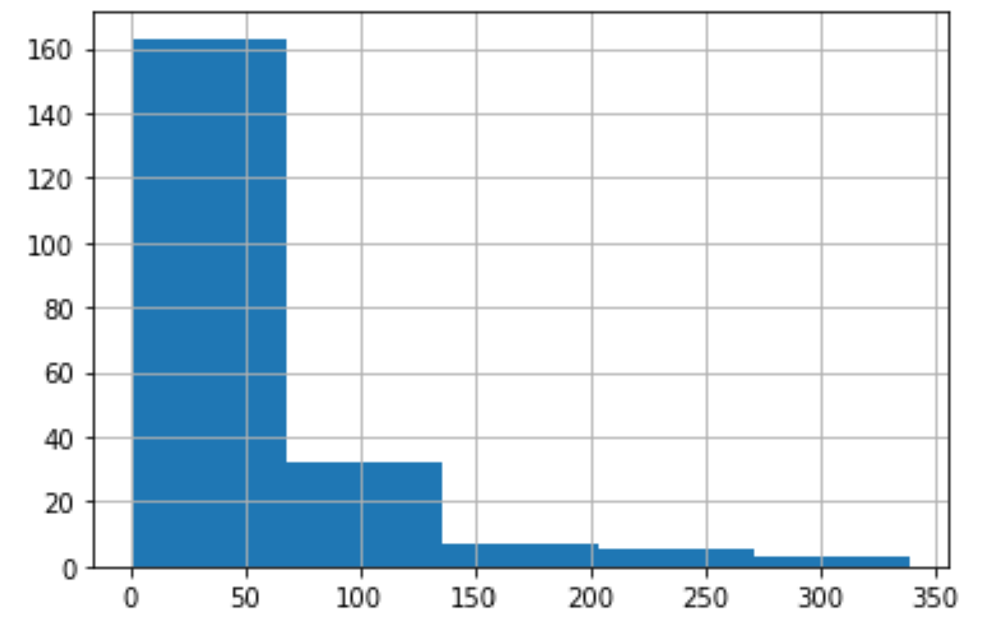

**Table with rating category for each restaurant**

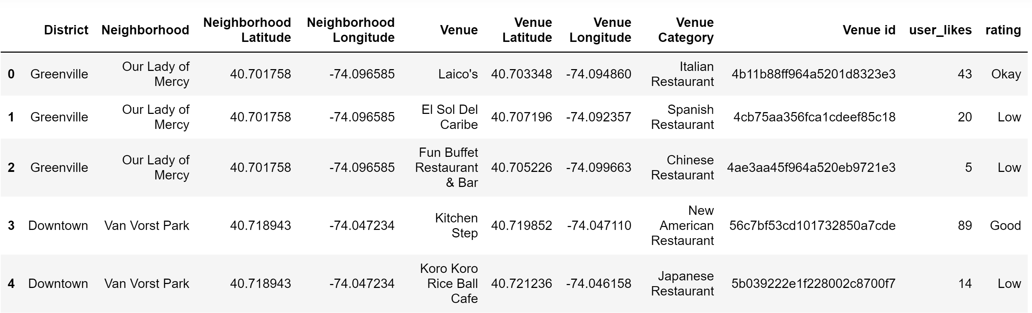

Moreover, I dug further and explored the most commonly found cuisines in each district and considered only the staple cuisines (‘American’, ‘Italian’, ‘Indian’, ‘Chinese’, ‘Mexican’ ) and color-coded them. I also categorized rest of the novelty cuisines as 'Other Novelty Cuisines' and color-coded them in white. Below is the resultant table.

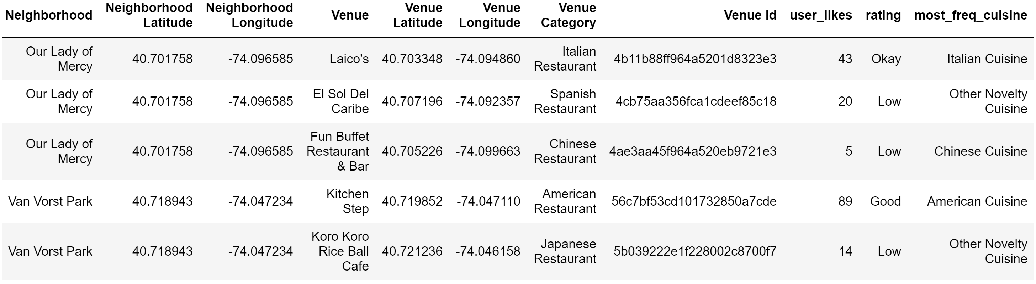

**C. Results and Discussion**

After cleaning the data and obtaining the aforementioned tables, I visualized the data using folium and choropleth maps to have the better view.

1. I visualized the clustered neighborhoods using folium library based on **Cluster Labels** column

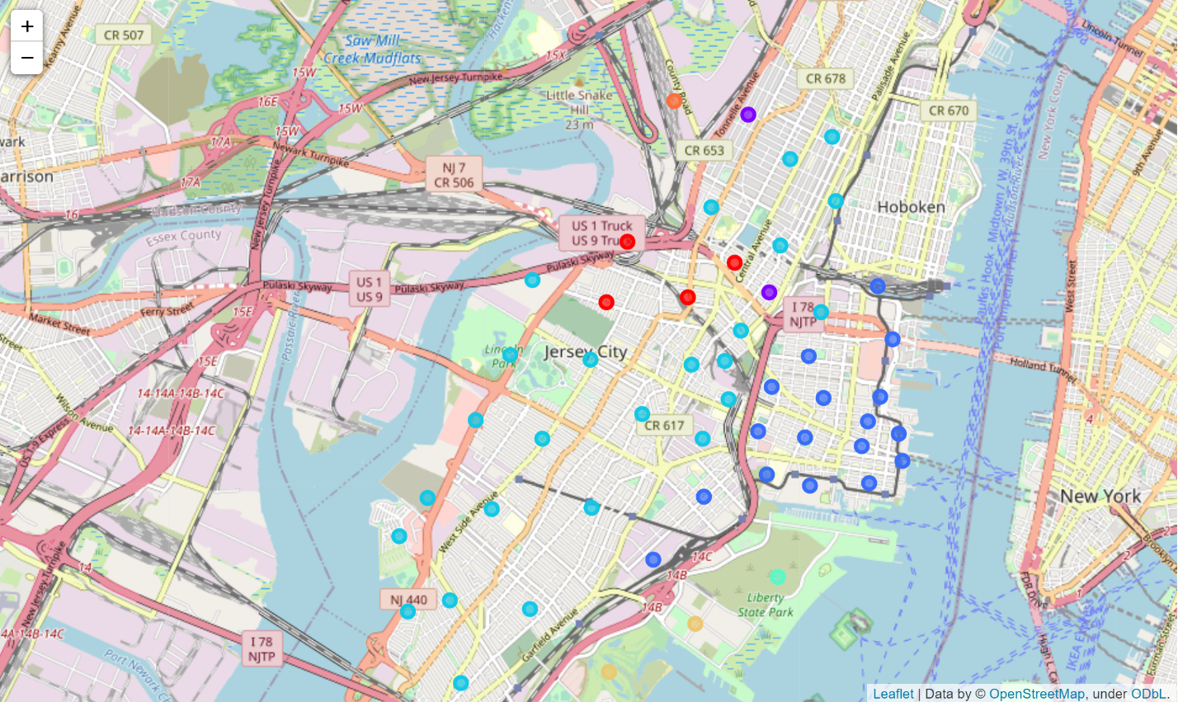

1. Next, I used a choropleth map to visualize the house affordability of Jersey City districts indicating the quantitative values of affordable housing units across the districts.

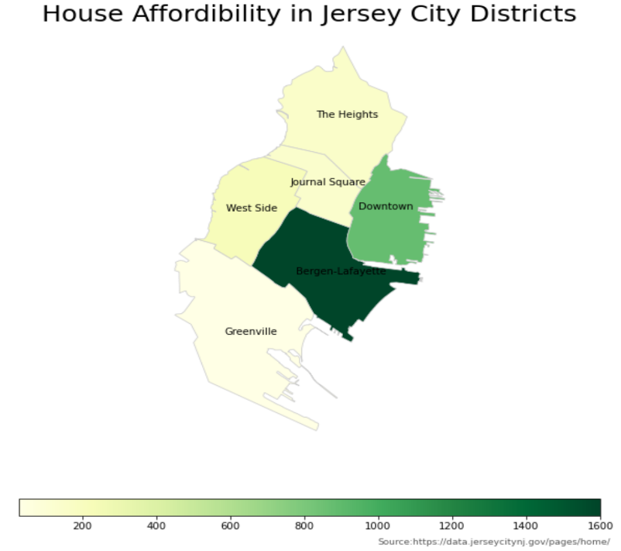

1. I also visualized the choropleth map showing house affordability with a layer depicting clustered neighborhoods on top using folium.

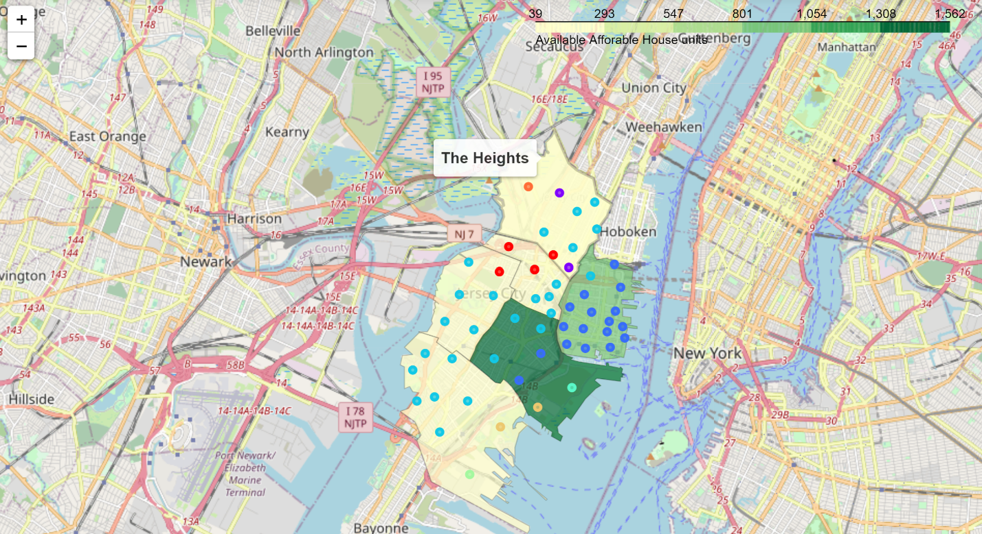

1. Visualization depicting the quality of restaurants in the Jersey City districts with color coding layered on top of choropleth map.

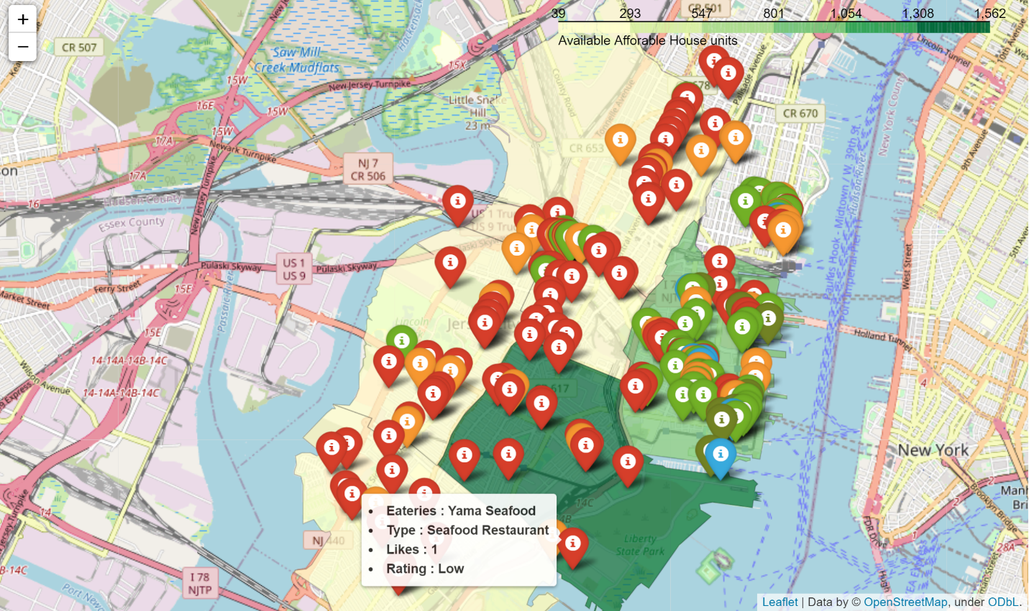

1. Finally, I visualized the frequently found staple cuisines using folium library layered on top of choropleth map depicting house affordability of Jersey City districts.

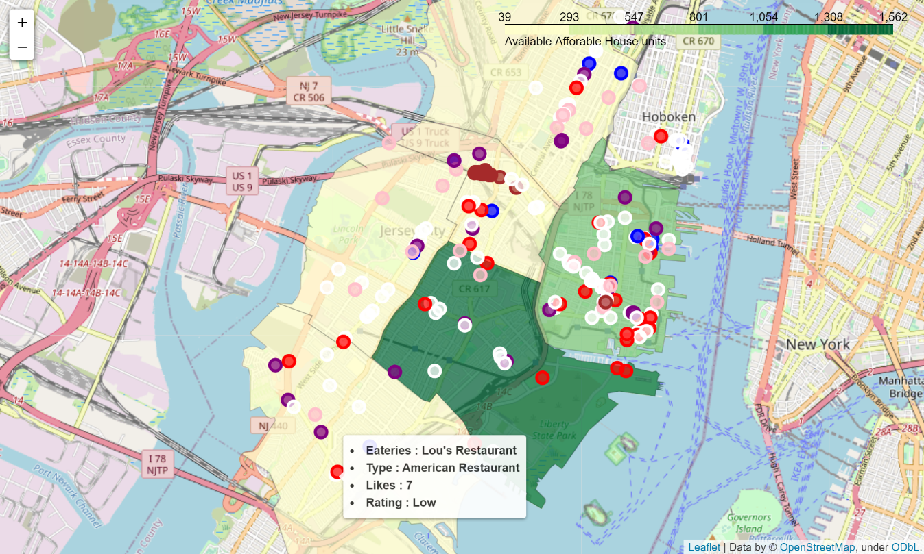

Overall, my aim was to explore the Jersey City and determine the areas to socialize, live and have regular meals. Choropleth map visualizations have the hover feature, which gives details for each restaurant and district name.

Clustering and segmenting using K means clustering revealed several clusters of neighborhoods with similar most common venue type characteristic.

Cluster 0 : Mostly have Indian restaurants in Neighborhoods belonging to Journal Square, The Heights, and West side districts.

Cluster 1: Mostly have grocery shops in neighborhoods like Palisade and Western Slope in The Heights district.

Cluster 2: Predominated by coffee shops, cafes, bars, American restaurants, bakery, and gyms in Downtown and Bergen-Lafayette districts.

Cluster 3: Consists of pizza places, Italian restaurants, fast food restaurants, Chinese restaurants, and parks in the neighborhoods belonging to Greenville, The Heights, West Side, Journal Square, and Bergen-Lafayette districts.

Cluster 4: Consists of science museum belonging to Liberty State Park neighborhood in Bergen-Lafayette district

Cluster 5: Comprise of business service center in Greenville Yards in Greenville.

Cluster 6: Comprise of golf courses in Port Liberte and LSP Industrial neighborhoods of Greenville and Bergen-Lafayette, respectively.

Cluster 7: Consists of a train station in Meadowlands neighborhood of The Heights district.

Furthermore, it is established that Downtown and Bergen-Lafayette have the greatest number of affordable housing units, hence are suitable to buy or rent a house. Moreover, Downtown have a wide variety of cuisines up for grabs, and most of them have better performance reviews. Exploring further, it is found that, **American, Italian, Indian, Chinese, and Mexican cuisines** are most commonly available in Jersey City, which are also considered as the USA's staple cuisines. American and Italian cuisine restaurants are more concentrated in **Downtown** neighborhoods. In contrast, Indian cuisine restaurants are heavily clustered around **Journal Square** neighborhoods, which also seems to be geographically close to West Side and The Heights districts. Other novelties and mixed cuisine restaurants are spread across the neighborhoods of Jersey City with no discernable pattern.

**D. Conclusion**

This analysis's objective was to find out the areas in Jersey City that are suitable to live, with regards to house affordability, availability of nearby good quality eating places, and type of venues common to different neighborhoods. Analysis results depicted that Downtown and Bergen-Lafayette are the most affordable districts in terms of buying/renting a house, while only Downtown neighborhoods have more options to have a good quality regular meal. Indian cuisine restaurants are predominantly clustered around Journal Square. American and Italian cuisine restaurants are widely available across the districts but are mostly located around Downtown.